Customising Your Route Maps – A User’s Guide
(GCSE Mathematics and GCSE Statistics)

Route Maps offer a suggested route through the content of the specification, which may not match your plans for teaching. However, the maps are designed to allow you to add or amend content to suit your own teaching needs.

Amending the calendars

The calendar view is displayed below. The teaching topics, holidays and exam periods are all represented by “tiles” that can be moved to suit your requirements. Moving the tiles is simply a matter of dragging and dropping with the mouse. Though we have tried to use “standard” school holidays, there are variations between Local Authorities and you may want to set these dates first.

The teaching topics are designed to represent a sensible amount of time to cover the content in detail. However, you can alter the width of each tile to match how long you intend to spend on each topic. Once you have customised your Route Map, running it as a Slide Show causes all the hyperlinks in the document to become live – for this interactivity, simply run a Slide Slow and then click on a topic to be taken to the relevant topic pages.

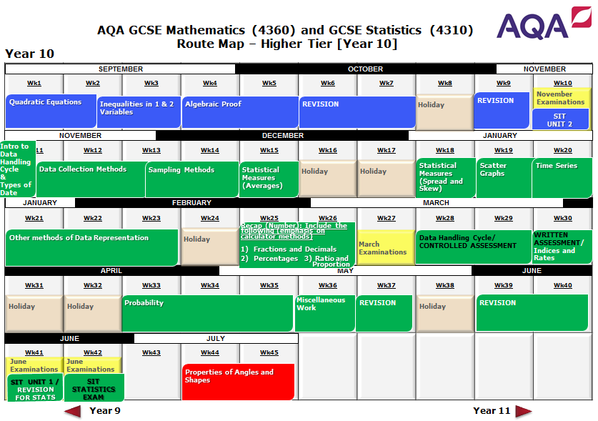

Running a Slide Show

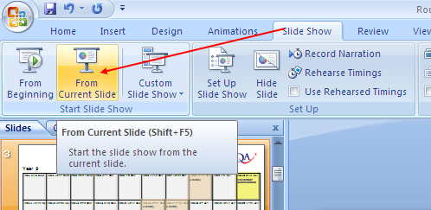

Functionality of the links

When running the PowerPoint as a Slide Show, the heading of each topic sheet for GCSE Mathematics (4360) acts as a hyperlink, taking you to the relevant page of All About Maths, and the resources held within it.

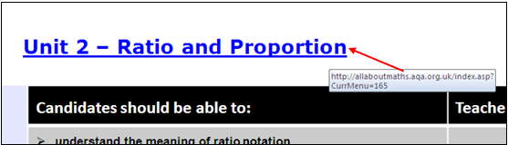

In the case of Statistics (since All About Maths is a site devoted purely to the GCSE Mathematics specifications), you will instead find links to an electronic version of the GCSE Statistics (4310) specification.

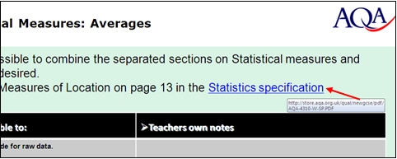
The relevant pages of the Statistics specification are listed on the topic slides; the page references are to the pages of the specification itself and not the pages of the PDF file (which includes the front cover of the specification as a page, etc.)

To optimise your settings for viewing the specification online, you should first rotate the page clockwise (to view it in portrait rather than landscape mode) and then fit the page to the width of the screen.

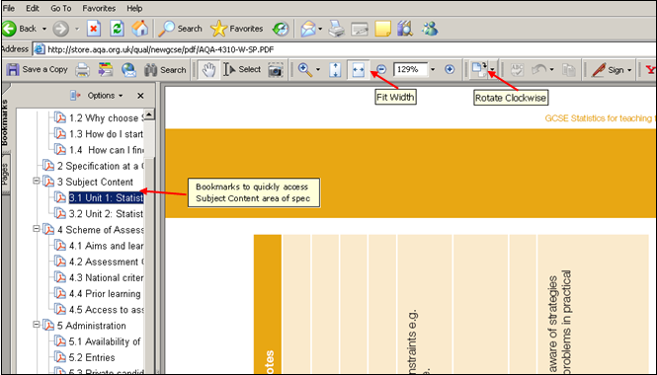

This will lead to the specification guidance being presented clearly on the screen, with additional notes available to view for the various topics.

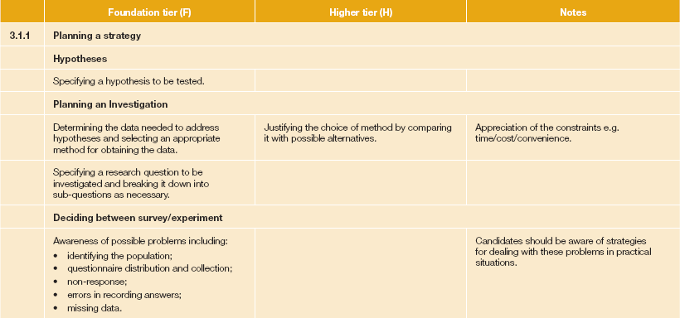
Additional notes provided in right hand column of the spec

Amending the topic sheets

Topic sheets have all the “candidates should be able to” statements, which are drawn from the specification references associated to the topic. You can amend these to reflect your own teaching order. Space is provided for you to add your own notes, or links to your own resources, so that you can use the Route Maps as the basis for a scheme of work.

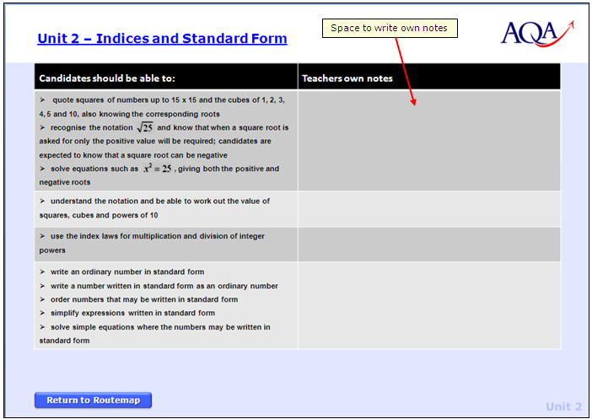

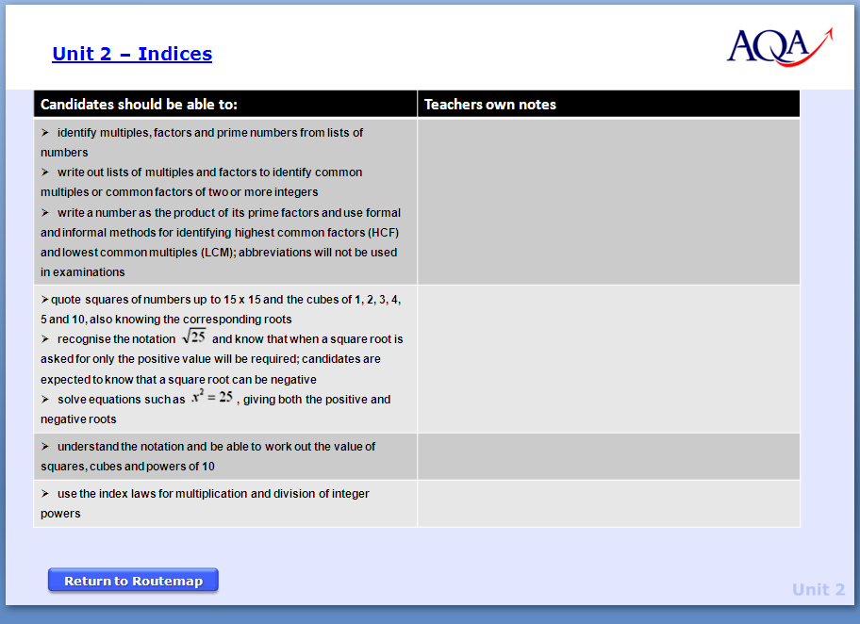

An alternative method of running a Slide Show to that demonstrated above may be required, depending on your version of Microsoft Office.

